**DAILY ONLINE ACTIVITIES SUMMARY**

|  |  |  |  |  |  |  |  |  |
| --- | --- | --- | --- | --- | --- | --- | --- | --- |
| **Date:** | **19-06-2020** | | | | | **Name:** | **Deeksha D Poojary** | |
| **Sem & Sec** | **VIII Semester & A Section** | | | | | **USN:** | **4AL16CS026** | |
| **Online Test Summary** | | | | | | | | |
| **Subject** | | **BDA** | | | | | | |
| **Max. Marks** | | **30** | | **Score** | | | **22** | |
| **Certification Course Summary** | | | | | | | | |
| **Course** | **Introduction to Amazon Elastic Compute Cloud (EC2)** | | | | | | | |
| **Certificate Provider** | | | **Amazon Web Service** | | **Duration** | | | **10 minutes** |
| **Coding Challenges** | | | | | | | | |
| **Problem Statement: Write a program for matric rotation** | | | | | | | | |
| **Status: COMPLETED** | | | | | | | | |
| **Uploaded the report in Github** | | | | | **YES** | | | |
| **If yes Repository name** | | | | | **deekshapoojari** | | | |
| **Uploaded the report in slack** | | | | | **YES** | | | |

Online Test Details:

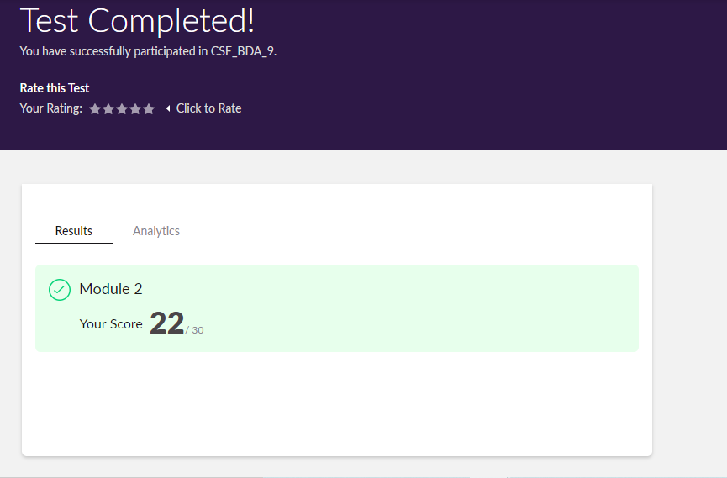

Certification Course Coding Challenges Details:

|  |
| --- |
|  |
|  |
|  |
|  |
|  |
|  |
|  |
|  |
|  |
|  |
|  |
|  |
|  |
|  |
|  |
|  |
|  |
|  |
|  |
|  |
|  |
|  |
|  |
|  |
|  |
|  |
|  |
|  |
|  |
|  |
|  |
|  |
|  |
|  |
|  |
|  |
|  |
|  |
|  |
|  |
|  |
|  |
|  |
|  |
|  |
|  |
|  |
|  |
|  |
|  |
|  |
|  |
|  |
|  |

**Program1:**

|  |  |
| --- | --- |
|  |  |

**#include<stdio.h>**

**void main()**

**{**

**int matrix[100][100];**

**int m,n,i,j;**

**printf("Enter row and columns of matrix: ");**

**scanf("%d%d",&m,&n);**

**printf("Enter matrix elements: \n");**

**for(i=0;i<m;i++)**

**for(j=0;j<n;j++)**

**scanf("%d",&matrix[i][j]);**

**printf("Matrix before roration \n");**

**for(i=0;i<m;i++)**

**for(j=0;j<n;j++)**

**printf("%d",matrix[i][j]);**

**printf("Matrix after Colckwise roration \n");**

**for(i=0;i<n;i++)**

**{**

**for(j=m-1;j>=0;j--)**

**printf("%d ",matrix[j][i]);**

**printf("\n");**

**}**

**printf("Matrix after anti Colckwise roration \n");**

**for(i=n-1;i>=0;i--)**

**{**

**for(j=0;j<m;j++)**

**printf("%d ",matrix[j][i]);**

**printf("\n");**

**}**

**}**